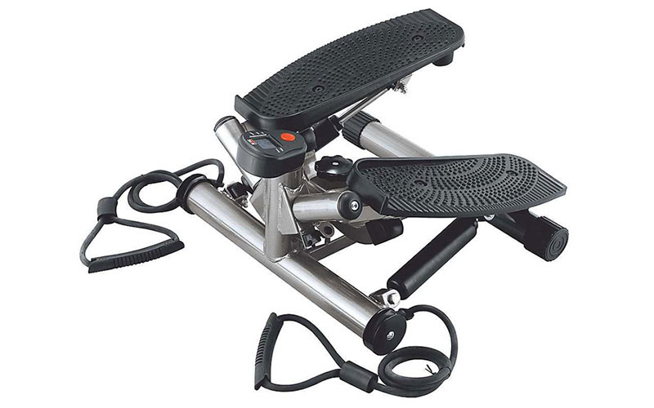

**Body Sculpture**

**SOLX-BS-1122SHA-B**

**Mini Stepper with Computer**

Ideal for professionals, amateurs as well as kids, this Mini Stepper With Computer from Body Sculpture improves your cardio endurance. This Body Sculpture Mini Stepper With Computer imitates the process of walking as if on the stairs and develops the inner surface of the thigh and leg muscles.

**Product Features**:

* Brand: Body Sculpture
* Model: SOLX-BS-1122SHA-B
* Sporting Goods Category: Exercise
* Material: Metal, plastic
* Color: Silver/black
* Maximum User Weight: 100 Kg
* Mini Stepper with computer for the home
* Strengthens the cardiovascular system and burns fat
* Imitation of walking as if on the stairs develops the inner surface of the thigh and leg muscles
* Enhances coordination, agility, speed, footwork and endurance
* Hydraulic cylinders, adjustable load level
* Indications on Computer: Training session, number of steps, scan mode, calories
* Improves breathing efficiency