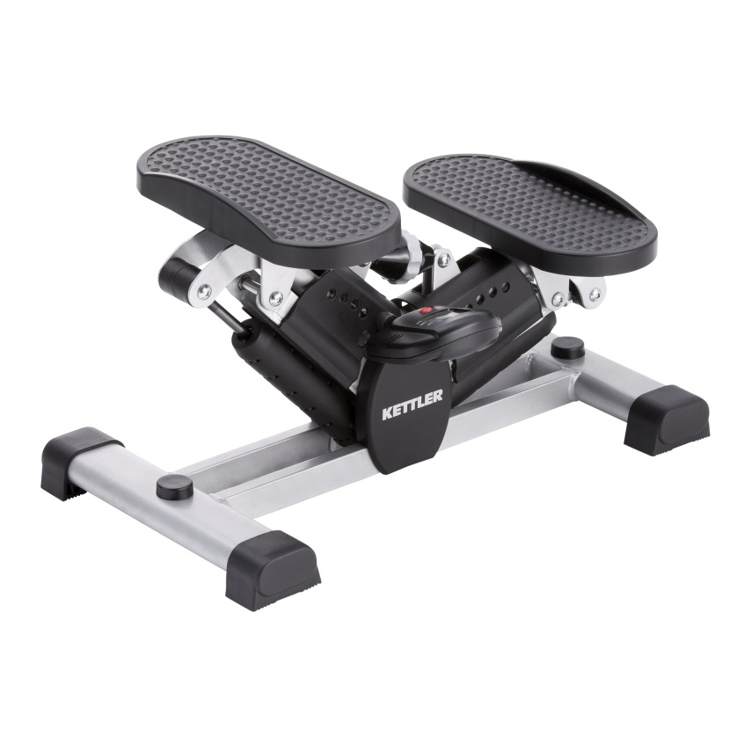

**KTLR7874-950**

**SIDE STEPPER**

**PRODUCT INFORMATION**

* SPECIFICATIONS

**Brand**

KETTLER

**Manufacturer Number**

7874-950

**Type**

Strength Training Equipment

* DESCRIPTION

Exercise stepper it's a great cardio that will allow you not only to disperse the blood and develop leg joints, but also significantly improve motor skills, coordination and overall physical health. The main purpose of the simulator is to tighten the muscles of the legs and buttocks, provoking weight loss and creating seductive body contouring.

**PRODUCT FEATURES :**

* + Brand: Kettler
  + Type: Strength Training Equipment
  + Model Number: 7874-950
  + Color: Multi Color
  + Braking system: 2 hydraulic cylinders
  + Details: Get rid of excess weight and tighten and strengthen the muscles of the buttocks and legs
  + Strengthen the respiratory and cardiovascular systems
  + Improve the sense of balance and develop coordination
  + Improve stamina and resistance to stress